**IDEA FRAMEWORK**

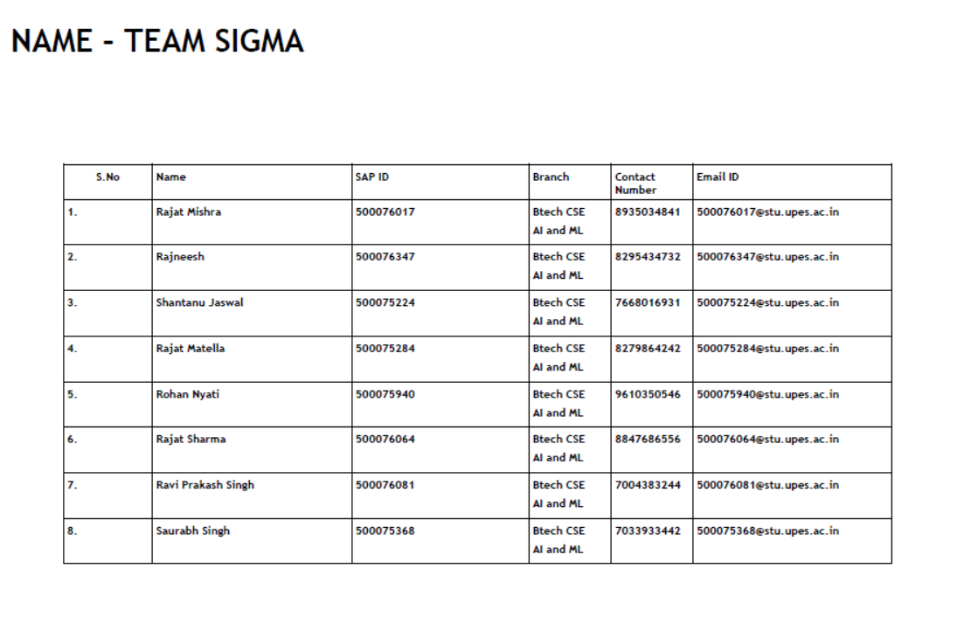

**1. Describe the idea and the need for Dropshipping**.

This idea aims to provide a platform to those who want to be start a business but lack capital to invest. Some people have the great mind but due to lack of financial backing stop them to enter into the business. Hence, this dropshipping technology will help those people as they don't have to invest anything except their minds.

Another idea behind this technology is to provide products at a cheapercost as customer will have an indirect connection with the manufacturer, or a wholesaler, or a retailer. Hence the intermediate person who is taking the order can work on less profit than the normal shopkeepers as they are not investing anything or close to nothing in terms of money and can provide products cheaper. This will lead to great exposure and expansion of the online businesses.

**2. What do you feel is the innovation over an existing solution to the problem that you are trying to address?**

**Lower start-up costs**

Businesses that adopt a dropshipping strategy don't have to invest capital in acquiring inventory or establishing a warehouse for it. They also don't have to spend time organizing their inventory or hiring a staff to manage orders. This means that dropshipping has a very low barrier to entry, as you can start a dropshipping business when you don't have the funds necessary to run a traditional retailing operation.

**Scalability**

A dropshipping retailer can scale up quickly because order fulfilment is not dependent on the size of a physical location or the number of workers needed to ship out an order. For this reason, dropshipping can greatly benefit retailers that experience fluctuating sales due to seasonal factors or other reasons.

**Lower inventory management**

By eliminating the need to maintain physical inventory, dropshipping reduces the management and maintenance overhead that retailers face. They do not need to spend time tracking inventory, managing the infrastructure that houses it, or managing shipping, which is outsourced to suppliers.

**Broad product offerings**

Dropshipping opens up more diverse product opportunities. Retailers can offer a wide range of products with dropshipping. Meaning a small scale business which would otherwise not be able to offer so many options without storage, would now be able to sell a broad selection.

**Flexibility**

Dropshipping brings flexibility to many facets of a retail business. A brand can operate from anywhere, offer different types of products, and change its offerings easily if market preference changes in future.

**3. Feasibility of the Idea: Viability of idea, pricing strategy, what resources will be used and the cost implications of the same. What are the risks involved?**

**Viability of dropshipping**

With the eCommerce industry becoming increasingly popular over the last 20 years and certainly picking up traction in the last 10, dropshipping has become an exciting and innovative new way for people to run a business without the need to buy a load of stock and find a warehouse to store it in.

There are several stats which show that the dropshipping industry is saturated, but there’s still a lot of potential and it’s nowhere close to dying. By 2025, market valuation of the dropshipping industry is expected to reach $557.9 billion.

Like Amazon, from one small online store to a globally-recognized retailer that makes over $280 billion a year

**Pricing Strategy**

**FMOC or fixed markup on cost** is a type of dropshipping pricing strategy that involves adding a pre-set profit margin to the cost of your products. You can either do this by the dollar or by percentage.

**Tiered markup on cost** is a price strategy most commonly used when the supplier has a variety of different products ranging from low to high in value. It allows you to not price your expensive items too high, but at the same time, you can make money from your low dollar items.

**MSRP (manufacturer’s suggested retail price)** is most commonly used by smaller dropshipping retailers who don’t want to deal with race-to-the-bottom price wars but still want to generate profit.

By pricing the products in accordance with suggested vendor retail prices you ensure you’re not outpricing the price the consumer will be expecting.

This is the strategy we will be making use of.

**Psychological dropshipping pricing strategy**

Some dropshippers may want to include a certain level of psychological triggering in their prices, where the price the customer sees is assumed to be cheaper than it seems. Sometimes we will be making use of this as well.

**Resources and cost**

Resources like eCommerce Platforms, hosting &domains , customer support , advertising platforms , product research , cashback systems , Design Tools and softwares/apps are required.

Since the industry is currently worth nearly $150 billion according to [in-](https://www.grandviewresearch.com/industry-analysis/dropshipping-market)[depth](https://www.grandviewresearch.com/industry-analysis/dropshipping-market)[research](https://www.grandviewresearch.com/industry-analysis/dropshipping-market)[on](https://www.grandviewresearch.com/industry-analysis/dropshipping-market)[dropshipping’s](https://www.grandviewresearch.com/industry-analysis/dropshipping-market)[market](https://www.grandviewresearch.com/industry-analysis/dropshipping-market)size and it’s still growing.

For the next 5 years the dropshipping industry is predicted to continue growing steadily.

So the cost of setting up our dropshipping store on an e-commerce platform and getting a subscription to an app/extension for importing products will be included.

There’s no better way to ensure the quality of a product than by checking it ourself. This will add to some cost.

Investing a small amount into additional software can make our dropshipping business run much more smoothly.

Finally marketing our product.Competing online is arguably the most challenging aspect of dropshipping. And it can be very expensive if it’s not done correctly.

Overall, the estimate that a realistic figure for starting a dropshipping business is around 21K to 30K Ind rupees.

**Risks involved**

Scammers :much of the business depends upon the quality of product, speed and delivery

Sometimes the delivery process can be interrupted by the scammers , leading to instant loss.

Small profit margins: less work means less profit, competition is more,and most suppliers works with multiple sellers on same products , thus we need to offer lower prices for the product.

Outdated Stocks and Overselling: we don’t have control over the supply chain, so if outdation or overselling occurs, our expenses comes down to merchant even if its fault of supplier.

Purchasing items from retail stores for discount and selling online at market price is again risky.

**4. Value Proposition: Elaborate the value for the customers and how the idea differentiates itself from rest of the competition?**

The customers will have to pay less than what they are paying now, as through this idea the intermediate person who is taking the order can work on less profit than the normal shopkeepers as they are not investing anything or close to nothing in terms of money and can provide products cheaper. This idea aims to provide a platform for those customers who want to start a business but lack capital to invest. Some people have the great mind but due to lack of financial backing stop them to enter into the business. Hence, this dropshipping technology will help those people as they don't have to invest anything except their minds. This idea is different as Businesses that adopt a dropshipping strategy don't have to invest capital in acquiring inventory or establishing a warehouse for it. They also don't have to spend time organizing their inventory or hiring a staff to manage orders. This means that dropshipping has a very low barrier to entry, as you can start a dropshipping business when you don't have the funds necessary to run a traditional retailing operation.